

***ASSIGNMENT NO. 02***

**FALL - 2022**

**DATE : 11/11/2022 SUBMISSION : 18/11/2022**

**Name: M Muaz Shahzad Enrollment: 02-131202-081**

**Q.1 ACCOUNTING EQUATION:**

1. Mr. Zahid commenced business with cash Rs. 100,000.
2. Purchased goods for cash Rs. 16,900.
3. Sold goods costing Rs. 11,900 for Rs. 18,200.
4. Purchased furniture Rs. 36,000.
5. Took a loan for Rs. 19,000 from bank.
6. Paid salary Rs. 9,600 and insurance Rs. 4,300.
7. Received Rent Rs. 6,200 and interest Rs. 2,800.
8. Paid Rs. 1,550 as premium of life insurance policy.
9. Purchased a bicycle for the owners’ son Rs. 2,290.
10. Depreciate furniture by 890.

**Solution:**

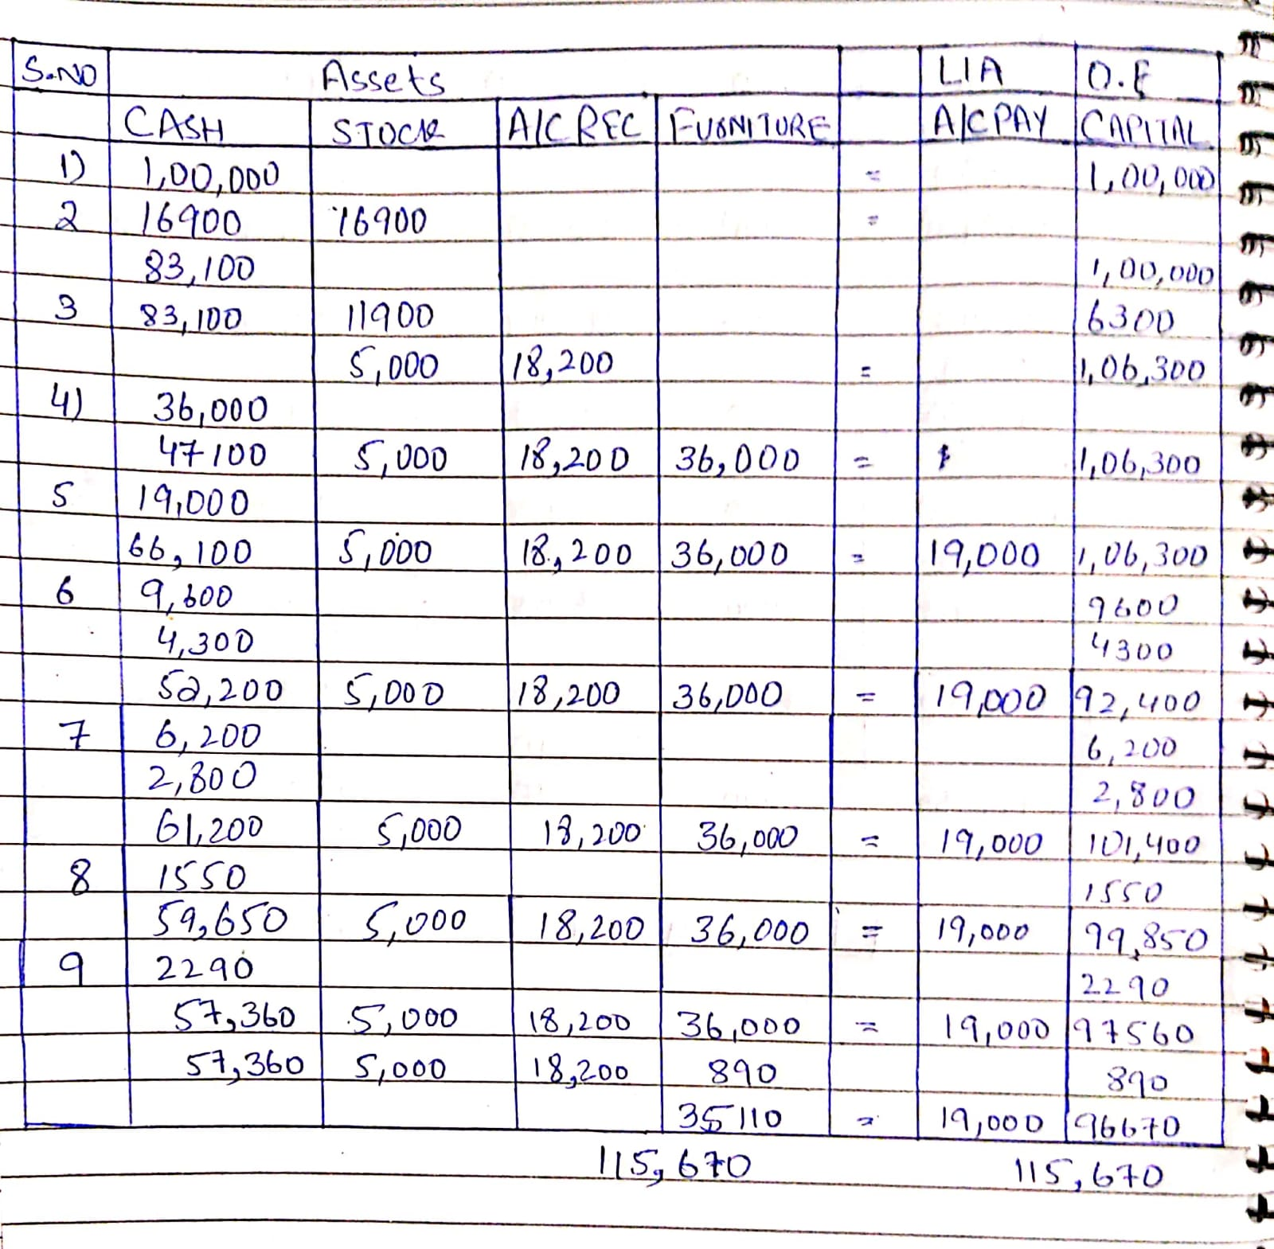

**Q. 2 Global (Pvt.) Ltd. is involved in Cloth trading, it performed the following transactions during the month of June 2014.**

1. Owner Mr. Kaleem invested the following in the business:
2. Cash Rs. 1,000,000, Building Rs. 1,600,000 & Furniture Rs. 200,000
3. Purchased vehicle for office worth Rs 350,000.
4. Purchased merchandise (cloths) worth Rs 400,000 on cash.
5. Purchased merchandise from ZEE (Pvt.) Ltd. worth Rs 100,000 on cash.
6. Sold cloths to Al-Abid textile for Rs. 500,000 from which Rs 300,000 on account.
7. Paid Salaries to employees Rs 500,000.
8. Paid fuel expense for vehicle Rs 100,000.
9. Received Rs. 150,000 from different customer.
10. Took cloths for personal use worth Rs 20,000.
11. Paid Rs. 50,000 as insurance premium for the next two months.

**Required:**

1. Record the above transaction in General Journal.
2. T-Accounts
3. Trial Balance

**Solution:**

**(a). General Journal**

**(b). T-Accounts**

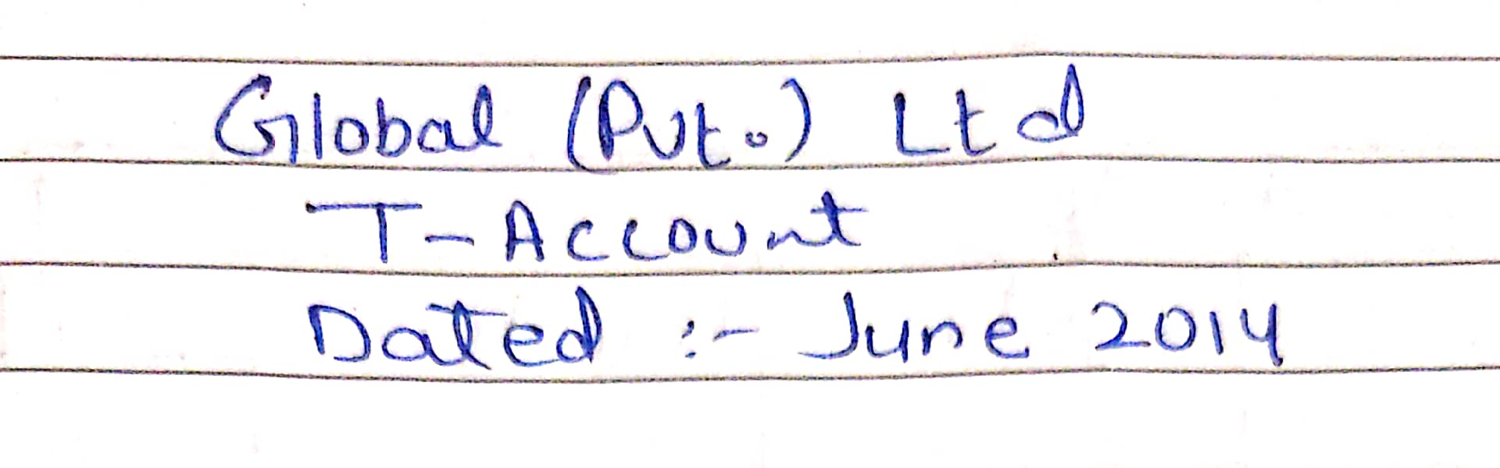

**(c). Trial Balance**

